Report - Y12Inquiry

Background
School infrastructure problems are not limited to just one school. They are part of a wider issue across New Zealand. A government report from the Ministry of Education shows that many schools have ongoing problems with property maintenance. This means that when infrastructure is damaged, the issue is not only the damage itself. It is also the inefficiency of the system used to report and fix it.

Reports on school infrastructure conditions show that some schools do not meet the standard people expect. This is often caused by old buildings, broken paths, and facilities that are wearing out. School property gets older over time, so some damage will always happen. But if there is no clear and regular way to report it, the same problems can sit there for a long time without being fixed.

Introduction
It is important for schools to have a good way to report damaged infrastructure. This helps keep the school safe and running properly. Students need working equipment and facilities every day. Students need them to do their work. They also need them to get to class and feel safe at school.

But a lot of students do not have an easy way to report damage. They may also struggle to show proof or explain what happened. This can cause mix-ups. It can also lead to false blame, unfair consequences, and slow action when something dangerous needs to be fixed.

Schools are changing and using more digital systems. Because of that, people also expect schools to be more reliable, more open, and more fair. To keep up with this, schools need to think about digital tools. These tools could make reporting easier, cut down extra admin work, and help schools deal with problems in a fairer and more consistent way.

Essential Question
How can students be supported by a digital tool to report damaged school infrastructure properly, give evidence when needed, and improve accountability while reducing confusion and delays?

Problems
Students and staff deal with the same problems again and again when school infrastructure gets damaged:

1. Reporting difficulties

Most schools still use old ways of reporting problems. Students might have to find a teacher, send an email, or fill in a paper form. These ways take time. They can also be messy and easy to forget during a normal school day. These mails may never be checked, maybe it is too late for checking — when the infrastructure is damaged for too long a time.

2. Lack of evidence

When something gets broken, students who were nearby can get blamed straight away. That is a problem. If there is no system for uploading photos, time records, or other details, it is hard to prove what really happened. It also makes it hard for students to explain their side clearly.

3. Delayed repairs and unclear communication

Because reports are scattered across emails or verbal complaints, maintenance staff may not receive them quickly—or at all. Students rarely receive updates about the status of repairs.

4. Misunderstandings and unfair accusations

Statements like “I didn’t do this! Then why did you report it?” highlight the unfair assumptions students may face. Without a structured and transparent system, students’ intentions are often misunderstood.

Evidence from Research and Real-World Observations

Research on school digitalisation suggests that:

Systems with centralised reporting improve response times and accountability.

Students experience reduced stress when schools implement transparent documentation processes for incidents.

When lots of people use the same equipment, it is easy for arguments to happen. No one is sure who caused the damage. Using digital logs and time stamps can help reduce this. It gives clear proof of what happened and when.

Some schools have started using apps to report maintenance issues. After that, fewer problems were left unfixed. This made the learning environment better. It also made classrooms safer.

Your draft also shows that students often find it had to defend themselves when they get blamed. This happens when there is no proper reporting system. A clear digital system, where students can add evidence, would help fix this problem.

Investigation
https://docs.google.com/document/d/1i87Nzk15i4OfFQ-uV93FMgUNW4JVMuavDK7f2Kxc9Fk/edit?tab=t.0

Government Source

Title
Report of the Ministerial Inquiry into School Property

Organisation
New Zealand Government – Ministry of Education

Key Findings

New Zealand spends billions managing school property infrastructure.
Schools frequently report delays, maintenance problems and management issues with school facilities.
Government reviews show a gap between expectations and delivery of school property management.

Quote
“There were many complaints from schools regarding the performance of the school property system.”

Relevance to Inquiry
This report shows that school infrastructure management is a national issue in New Zealand, not just a problem in one school.
Because many schools experience problems with property maintenance and reporting, it suggests that better systems for tracking and reporting infrastructure problems are needed.

Article

School maintenance data shows poor facility conditions in some schools.

Key Findings
- Government inspections rate schools on a facility condition scale.

- Some schools scored below average due to aging infrastructure.

- Reports examine buildings, fences, paths and other facilities.

Quote
Schools were assessed on buildings, footpaths, fencing and structures.

Relevance
This shows that public school infrastructure problems are common.
Because many facilities age or break over time, schools must have clear systems to report and prioritise repairs.

Public Infrastructure Reporting Platform

Platform
Snap Send Solve

What it does
- Citizens report public infrastructure issues using photos.

- Reports include location and images.

- Reports go directly to the responsible authority.

Key Data

Over 4.5 million public issue reports submitted in 2024.
Used by local councils and authorities in Australia and New Zealand.

Quote
The platform simplifies reporting community issues to authorities.

Relevance
This is a real-world example of a digital reporting system for public infrastructure.
A similar system could be used in schools. Students could report damaged facilities by uploading photos and short descriptions.

Source Reliability

The sources used in this inquiry are reliable and relevant.

The Ministry of Education report is highly credible because it is an official government source. It is based on national data and reflects real issues experienced by school across the country.

News articles provide additional context and show how these issues affects schools in real situations. While they may not be as formal as government reports, they still offer useful supporting evidence.

Snap Send Solve is a real-world platform used in New Zealand and Australia. Its large number of reports and practical application demonstrate that digital reporting systems can be effective in real environments.

Using a combination of these sources strengthens the reliability of the findings.

Conclusion

This inquiry shows that current school infrastructure reporting systems are often inefficient. They can also be unclear. Many students also find them hard to use.

The research identified several key problems. Reporting processes are slow. There is often a lack of evidence. Communication between students and staff is also poor.

A digital reporting system can help solve these issues. Students can submit reports easily. They can upload evidence. They can also track the progress of their reports.

Therefore, the proposed digital system answers the inquiry question directly. It provides a clear and structured way to report problems. It is also more efficient. It can help improve accountability in schools.

Consequences of Inaction
If schools fail to improve their infrastructure reporting systems:

Minor problems may escalate into safety hazards

Students may continue facing unfair disciplinary action

Damage may remain unrepaired for long periods

Students can start to lose trust in the school. They feel like things are not handled clearly or fairly.

Problems are sometimes noticed too late. This can make repairs cost more than they should.

In the end, this affects how students feel at school. It can also affect how well they learn.

Ways to improve reporting and how schools deal with these issues.

Right now, schools mostly use paper forms, quick chats in the hallway, or emails to teachers. These ways do not work well anymore.

So schools could start using digital tools instead, for example:

A web-based reporting portal

A mobile app with photo and video upload features

QR-code based reporting at each facility

Automated ticketing workflows for maintenance staff

Real-time notifications for students regarding the status of their reports

These approaches reduce barriers for students and support more consistent documentation.

Refined Inquiry Question

How can a digital reporting system be designed to help students document and report damaged school infrastructure clearly, record what happened with evidence, and communicate with school staff in a fast and organised way?

Analysis of Research Findings

Research from government reports, news sources and public infrastructure platforms shows several consistent patterns. This shows a problem is kind of long-term neglect by the government.

First, problems with schools infrastructure are well known. A New Zealand government inquiry into school property found many complaints from schools about how the property system works. This shows that these issues are not just one-off cases. They are part of a bigger system problem.

Second, news reports show that many schools have ageing buildings and worn-out facilities. Things like fences and pathways need regular maintenance. If reporting is slow or not clear, these problems can stay unfixed for a long time.

Third, platforms like Snap Send Solve show how digital tools can make reporting easier. People can send reports with photos, short descriptions, and locations. This helps authorities see the problem clearly and fix it faster.

When these sources are compared, one main idea stands out. Infrastructure problems cannot be fully avoided. But how fast they get fixed depends a lot on how good the reporting system is.

These findings suggest that a clear digital reporting system could help students and staff communicate better. It can also provide proof of damage and reduce misunderstandings.

Key Patterns Identified
From the research, some clear patterns can be seen.

First, infrastructure problems happening in many school in New Zealand. This means the issue is not just in one place. It is part of a wider system problem.

Second, reporting systems are often slow. They are also inconsistent and sometimes unclear. Report can get lost. They can be delayed. Sometimes they are not communicated properly.

Third, there is often no strong evidence when damage happens. This makes things confusing. People may get blamed unfairly. It is also hard to know what actually happened.

Gap Identified
Right now, there is no simple and student-friendly solution of the digital system. Student cannot used easy way to report infrastructure damage. They also cannot provide evidence or track their report clearly.

This shows there is a gap. A more structured and easy-to-use digital solution is needed.

Additional Synthesis of Research Findings
Combing government sources, such as the 2024 Ministerial Inquiry into School Property, with real-world examples like Snap Send Solve shows deeper patterns.

The Inquiry (June 2024) found that the school property system is “not fit for purpose.” Many schools experience delays. Buildings are often not well maintained. There is also a lack of transparency in how work is prioritised. As a result, schools often complain about slow repairs.

Snap Send Solve, which is used in New Zealand and Australia, shows how digital systems can work well. Millions of reports have been submitted. Most reports include photos, with very high rates(around 95% in NZ data). This leads to faster responses. It works because of photo evidence, location tagging, and direct routing to the right authorities.

The key insight is that infrastructure damage cannot always be prevented. This is mainly due to aging buildings and assets. However, response speed, fairness, and accountability depend on good evidence and clear communication.

Traditional school methods, such as emails or paper forms, are less effective. Reports can be lost. There is often no clear proof. This can lead to unfair blame and delays.

Platforms like Snap Send Solve show that using photos and metadata can greatly improve outcomes. However, schools need a more suitable version. It should have closed access. It should also be simple and student-friendly.

Gap Reinforcement
There is currently no digital tool designed specifically for New Zealand schools. Students do not have an easy way to report issues. There is no system that combines evidence upload, status tracking, and staff integration in one place.

This shows a clear gap. It also creates a strong opportunity for a targeted digital solution.

Impact of Research on Proposed Outcome
The findings from the research had a clear impact on the design of the proposed digital system.

Because current reporting systems are slow and inconsistent , the new system will have a simple and fast reporting process. Students can submit issues quickly. It should only take a short time.

Because there is often a lack of evidence, the system will allow users to upload photos. They can also add details like time and location. This helps make the report more accurate. It also reduces unfair blame.

Because communication is often unclear, the system will include a tracking feature. Students can see the progress of their report. They can also check its current status.

Therefore, the proposed system is designed to solve the main problems found in the research. It also aims to improve how infrastructure issues are managed in schools. This directly answers the inquiry question by providing a structured and evidence-based reporting solution for students.

Purpose

Used the digital outcome to create a system that lets students report damaged school infrastructure quickly and accurately.

End Users

Primary users include students who need to report issues with school facilities.
Secondary users include school administrators and maintenance staff who manage and repair infrastructure.

Scope

The system will allow students to:

- report infrastructure damage

- upload photos as evidence

- include location information

- track the status of their report

The system will not include full building management tools or complex maintenance scheduling.

Requirements

The digital outcome must:

- allow students to submit reports easily

- allow photo evidence uploads

- record timestamps and locations

- allow staff to view and manage reports

- provide status updates

Specifications

The system should:

Work on mobile devices and computers

Have a simple user interface

Store reports in a database

Allow staff to mark issues as resolved

Resources

Resources | Description
Hardware | Basic physical equipment needed is a device that can use and can run program and design software.
Software | The website will design used HTML, CSS, and JavaScript, and universally played on the web.  First draw will be at Figma, and for next as initial concepts.
Time | The basic deadline within school gives, and my personal problem, the allocated time to complete the design concepts is the end of term 1 or the 13th of April.  For making the digital outcome, the allocated time to complete the website will be of next terms.
Materials | Not applicable
Expertise | Basic knowledge of HTML, CSS, JavaScript, and as well as navigating through.

Implications and Considerations
A digital reporting system can help solve inefficiencies. But it also brings new issues. These need to be considered from different perspectives.

Privacy and Ethical Considerations
Students may upload photos of damage. In some cases, other students or staff may appear in the background. Personal information could also be captured. This creates privacy risks under New Zealand's Privacy Act 2020.

To reduce this risk, the system should include basic protection tools. For example, automatic face blurring using simple image processing. Another option is to require users to crop or mark only the damaged area.

From an ethical point of view, anonymous reporting could be included. Students would not need to link their names unless they choose to. This can encourage more honest reporting. It also reduces fear of getting into trouble. However, it may increase false reports. This can be managed with a staff moderation dashboard.

Accessibility and Equity Perspectives
Not all students have the same access to technology. Some may not have smartphones. Others may have low digital skills. This includes younger students, students with disabilities, or those from lower socio-economic backgrounds.

The system should be mobile-friendly. It should also be simple to use. Features like voice-to-text can help with descriptions. A high-contrast interface can support visibility. Clear and simple language should be used.

From a staff perspective, more reports may increase workload. Maintenance teams could become overloaded. To manage this, the system should include auto-prioritisation. For example, reports can be tagged by severity, such as “safety hazard”. This helps staff focus on urgent issues first.

Accuracy and Misuse Risks
If reporting is too easy, some students may submit fake or prank reports. Schools are concerned this could waste time and resources.

To reduce this risk, photo evidence should be required. The system can also include basic verification, such as CAPTCHA. It can log device or IP data for repeated misuse. This should be done carefully to avoid privacy issues.
These implications have a direct impact on the design. Mandatory evidence helps reduce misuse. Anonymous reporting helps build trust. Prioritisation helps staff manage their workload more efficiently.

Designing The Digital Outcome

Conventions In My Outcome
In my project, following the specification is more important for my project. In New Zealand, The conventions I have researched for my website to address are: Usability Heuristics, Grid/Layouts, User Interface(UI) and User Experience.

Usability Heuristics:
Usability heuristics talks about the fundamentals of making an outcome usable. The 10 heuristics
include:
1) Visibility of System Status - ensures that the user knows what’s going on
2) Match Between System and the Real World - ensures that the user is familiar with real-world
conventions
3) User Control and Freedom - ensures that the user can undo an input without extended time.
4) Consistency and Standards - ensures that the users don’t need to question whether if
different things mean the same thing.
5) Error Prevention - ensures that the user knows what input that they’re doing and confirms.
6) Recognition Rather than Recall - ensures to minimise the users memory. It’s easier to
recognize rather than recall something.
7) Flexibility and Efficiency of Use - ensures to cater towards advanced and novice users, i.e
shortcuts.
8) Aesthetic and Minimalist Design - ensures that the website doesn’t include unnecessary
information.
9) Help Users with Error - ensures users know what went wrong in case of an error, i.e no code
and simple messages.
10) Help and Documentation - ensures that the users can get help for using the website.

The 10 rules are the base of the project need, following these rules can make my website easy to use. Make sure users can know how to navigate around my project. what everything
means and how they can get what they want.

Applying Conventions in My Design

This project used design conventions to guide the interface design.

I focused on usability first. I made the system easy to understand and easy to use. For example, I used colour on the report list page to show the status of each report. This helps users see the situation fast. This follows the idea of visibility of system status.

I also used clear labels and simple words in the report form. Users can understand what to do right away. They do not need to remember extra steps. This follows the idea of recognition rather than recall.

I improved user control in the system. I added simple navigation buttons. Users can go back to the previous page. Users can fix mistakes and move around with ease.

I kept the design consistent. I used similar layouts and styles across all pages. This helps users learn the system faster. It also makes the system feel stable.

I used a simple grid layout. I grouped information into clear sections. These sections include input fields, report details, and status. This makes the page more organised. It also makes the content easier to read.

I focused on a clean user interface. I used simple visual elements. I did not add too much content on the screen. This follows the idea of simple design.

I also thought about user experience. I made the process fast and clear. Users can report an issue in a few steps. Users can also check the progress of their report. This makes the experience smooth.

These design conventions guided my decisions. They helped me build a system that is clear, simple, and easy for students to use.

Initial Concepts & Feedback

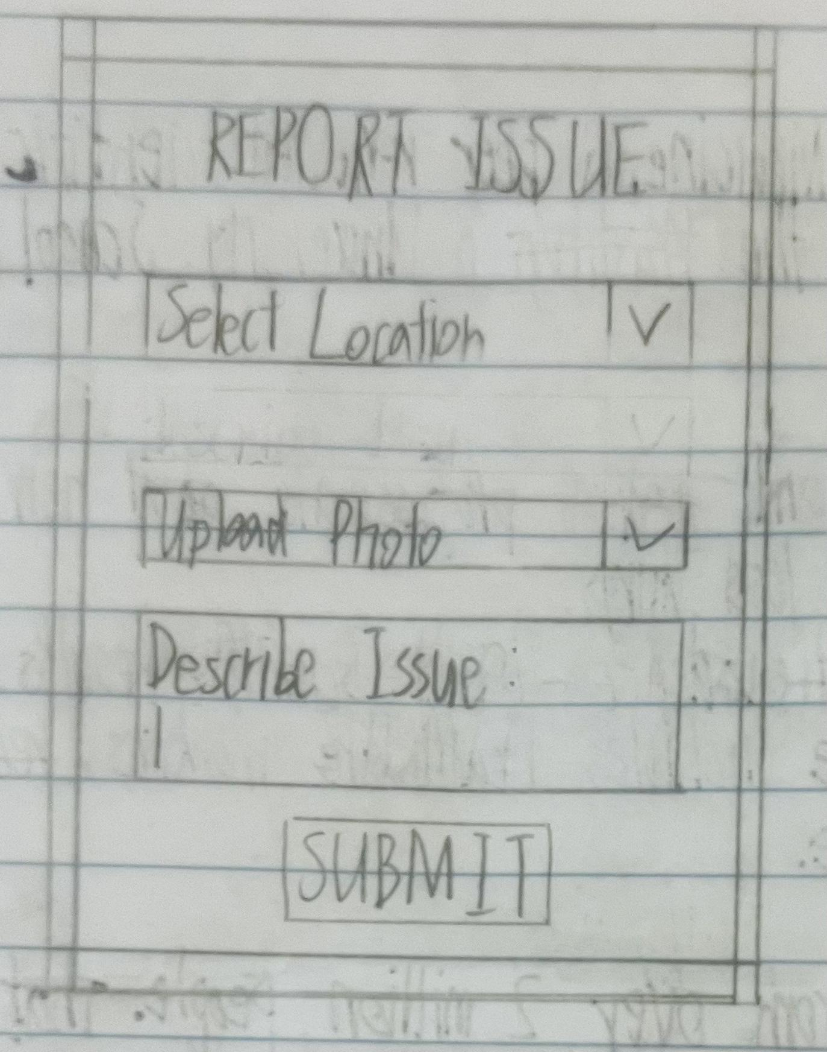 | Report Menu  Feedback:  “I don’t quite understand what this box means. And the page looks too empty, and I wasn’t sure if I clicked ‘SUBMIT’ does it really upload.”
This initial concept/task was about sketching the first ideas for the report page of the website. The concept was using simply a piece of paper, a pencil, rubber and a ruler to design. The page includes location selection, photo upload, and a description box. It ends with a submit button.

The feedback I got was that user did not know what to write in the description. Some users were confused the issue type. Some users also said the page looked too plain.

I will refine this concept based on the feedback. I will add placeholder text to guide users. I will make the labels more clear. I will also improve the layout to make it look more structured. This will help users complete the form more easily and reduce mistakes.
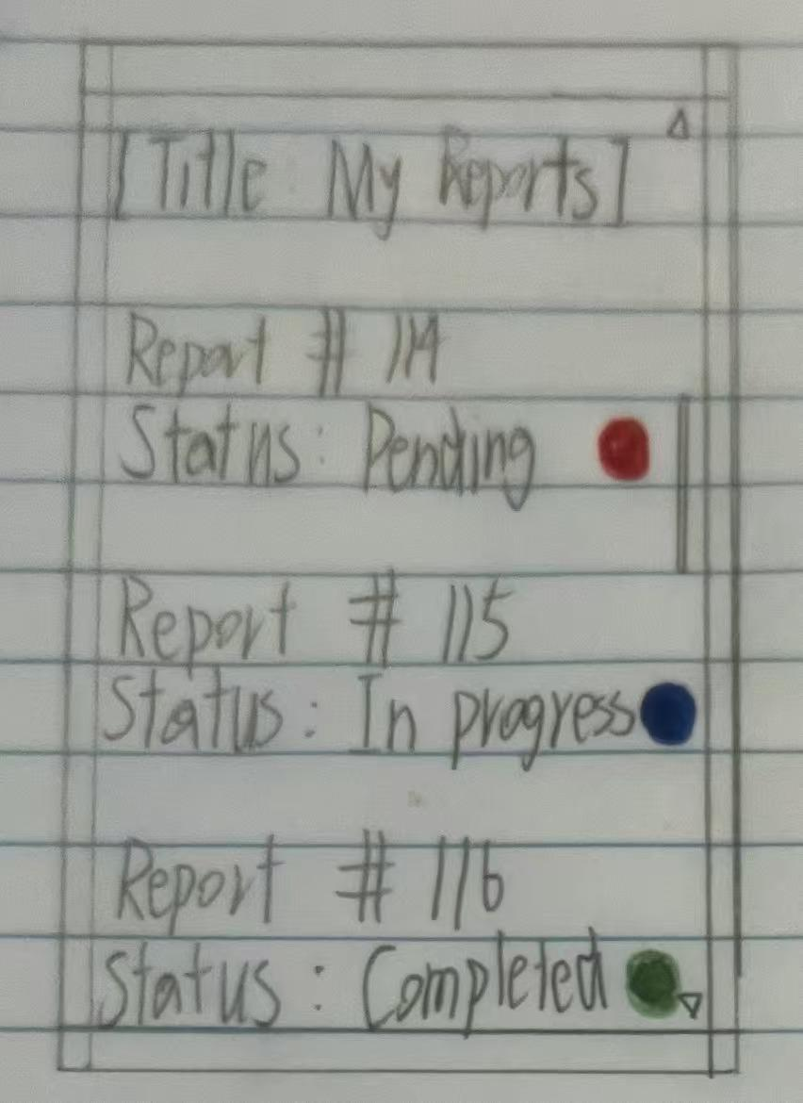 | My Report Page  Feedback:  “I don't know what the colour means first. It is not clear what kind of issue I should select. And this page looks too boring.”
This initial concept was about creating a simple screen where users can view all their reports.

I drew this design using paper and pencil to quickly explore my ideas. The page shows a list of reports. Each report has a number and a status. The status uses colours to help users understand it faster.

The feedback I received said that meaning of the colours was not clear at first. Some users also said the page looked too empty. Others said they were not sure if they could click on the reports.

I will refine this design based on the feedback. I will add text labels next to the colours to make the meaning clearer. I will make the reports look clickable so users know they can interact with them. This will make the screen easier to understand and use.
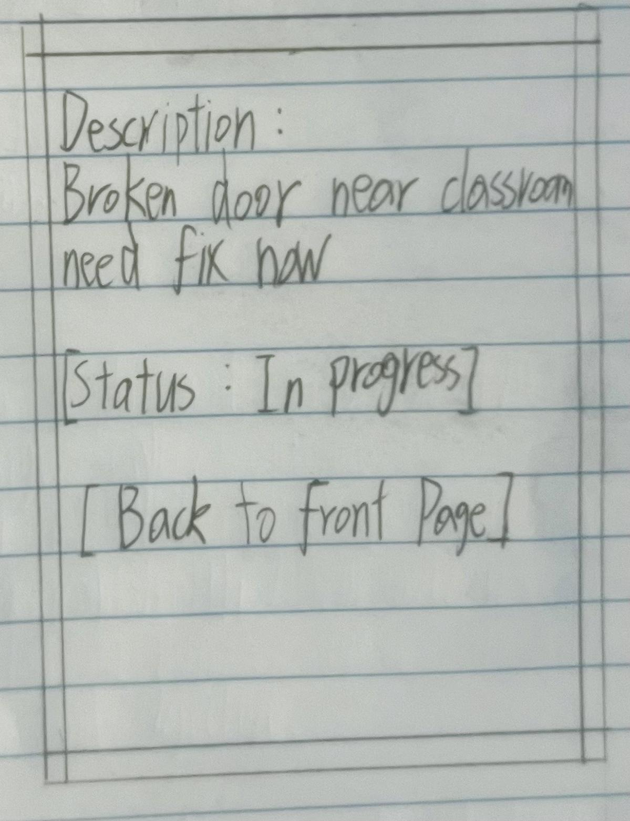 | Detail Page  Feedback: “I guess there is not much information here. It look too young to simple, and I want see more details like time.”
This initial concept was about showing the details of a report. I used a simple layout to display the description and status. The goal of this screen is to let users quickly understand the report information.

The feedback I received said that there was not enough information on the page. Some users said the design felt too simple. Others wanted to see more details such as location and time.

I will refine this design based on the feedback. I will add more information fields such as location and time. I will also improve the layout to make the information clearer. This will make the page more useful and help users understand the report better.
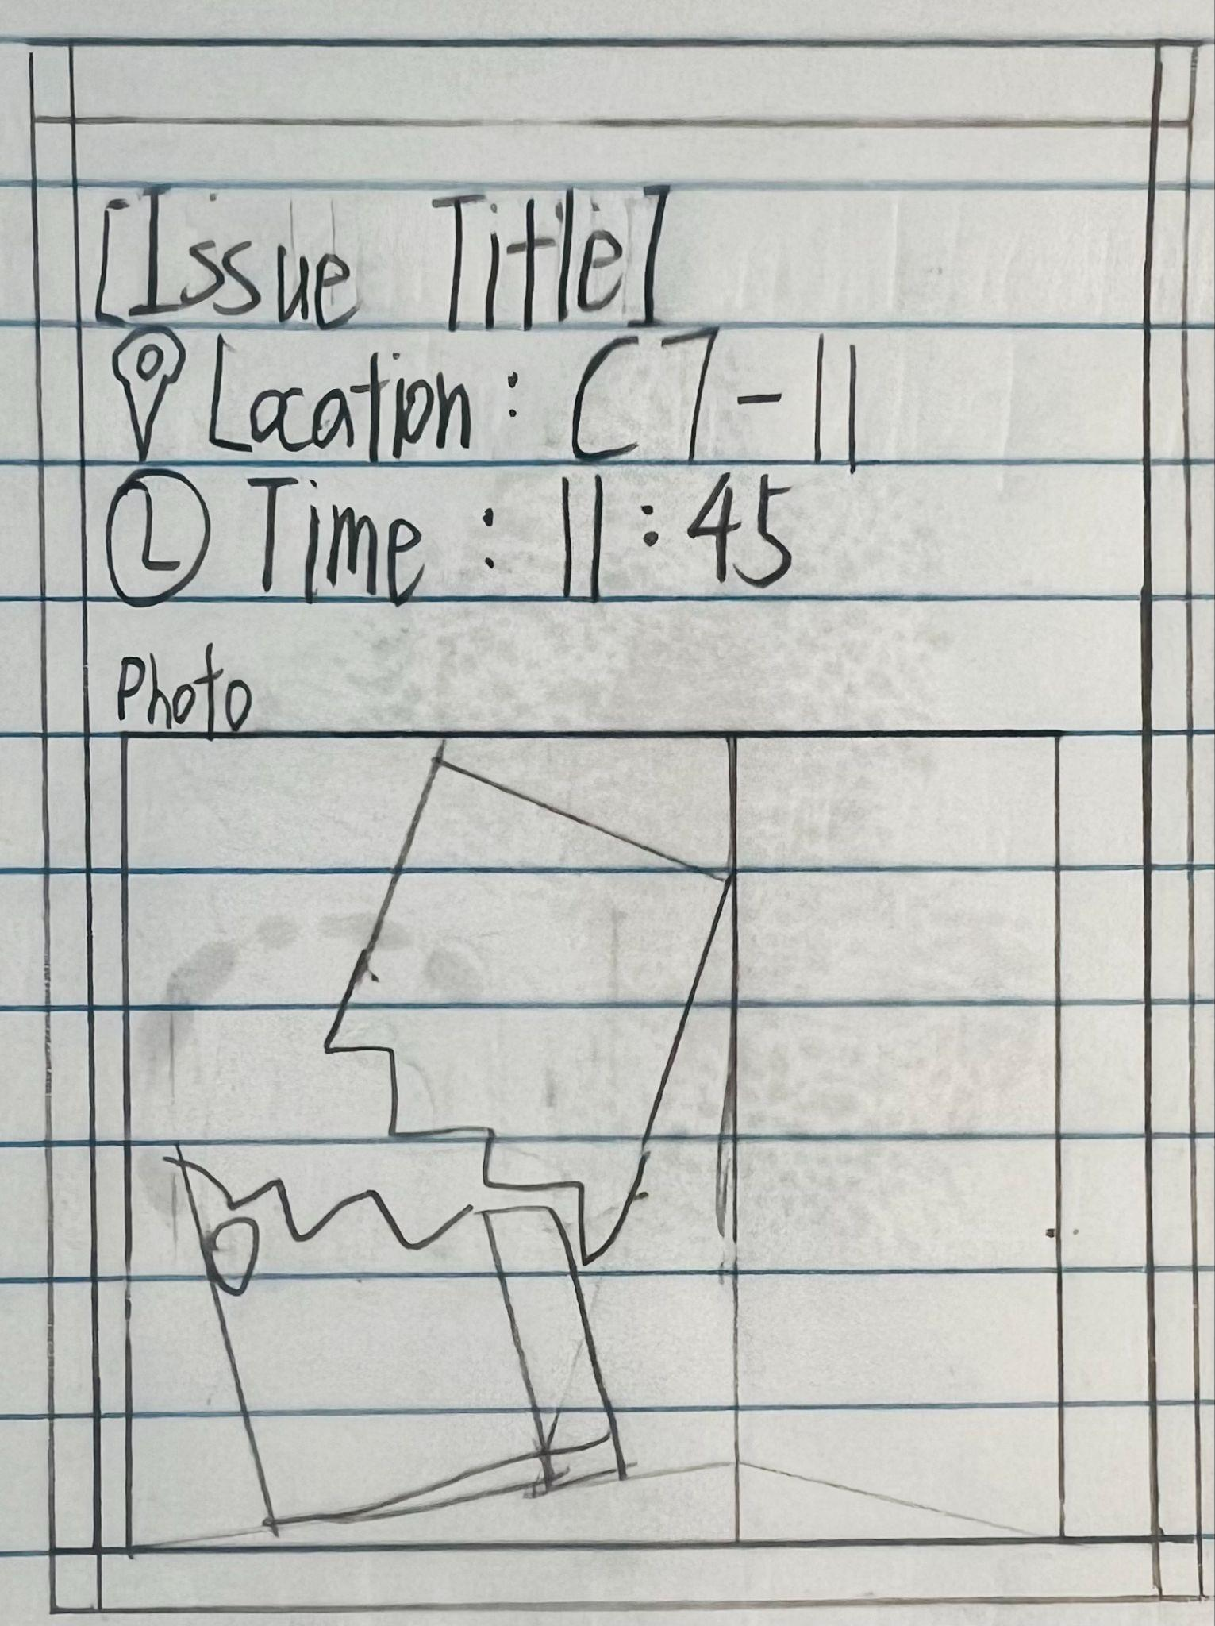 | Detail + Photo  Feedback: “The photo is good but is too big. And the layout is look messy, I don’t know what some icon means.”
This initial concept was about creating a more detailed report page. I include location, time, and a photo to provide full information. I also used simple icons to make the information easier to read.

The feedback I received said that the photo was too large. Some users said the layout looked messy. I will organise the layout to make it cleaner.

I will also improve the icons and add labels if needed. This will make the page clearer and easier to use.

Refined Designs & Feedback

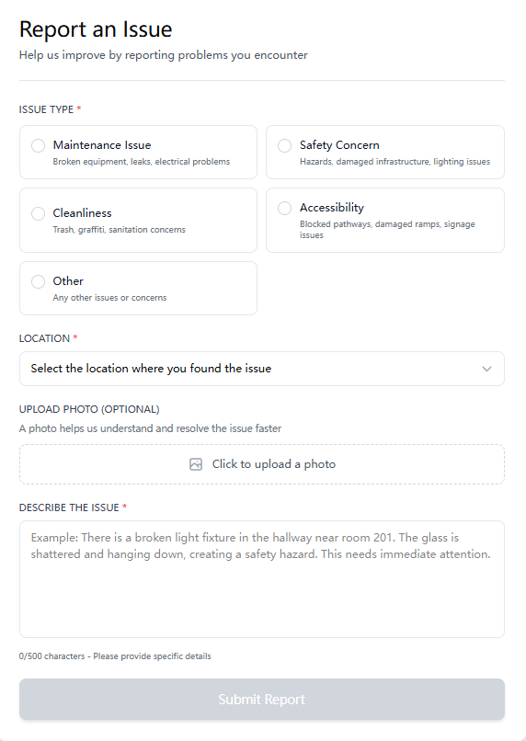 | Feedback:  “The form looks clear, but I was not sure what I should write in the description. Some options are good, but I feel like I need more guidance. The submit button also looks inactive or unclear.”
This task was about further refining the issue reporting form after the first version.

In the previous design, I already added structure and basic input fields. However, users still needed more guidance when filling in the form.

To improve this, I added example placeholder text in the description box. This shows users what kind of information they should write.

I also improved the labels for issued types to make it more descriptive. This helps users understand when they are able to submit the report.

These improvements support usability reduce user usability and reduce user confusion. It follows usability heuristics such as error prevention and recognition rather than recall.
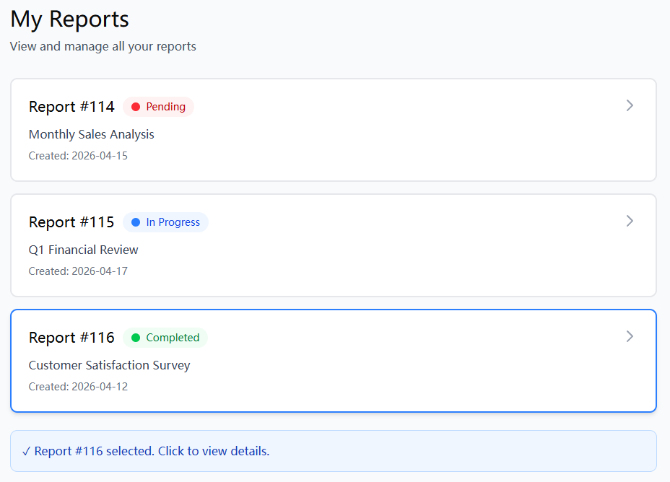 | Feedback:  “The layout is clean and easy to read. The colours help, but I was not sure what each colour means at first. I also was not sure if I could click on each report.”
This task was about further refining the report list page after the first digital version.

In the first refinement, I already added colour and improved the lay out. However, based on the new feedback, I noticed that users will still be unsure about the meaning of colours and Interaction.

To improve this I added clearer status labels next to each color。 These help users understand the “Pending”, “In Progress” and “Complete” without the guessing.

I also improve the visual design of each report card. I made the card look more clickable by adding spacing, borders and hover-like visual feedback。This helps users understand that they can select a report.

These changes improve the usability，because users can not understand the system strangers more easily. It also follows usability heuristics such as visibility for system structures and consistency.
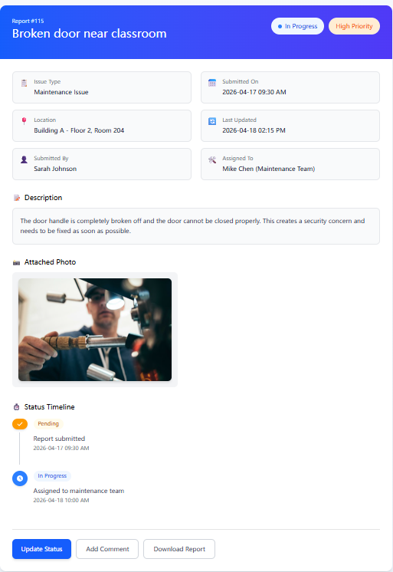 | Feedback:  “The page looks good, but I want to see more details. The layout is clear, but the sections could be better separated. The timeline is helpful but not very obvious at first.”
This task focused on improving the report detail page after the first digital version.

Users liked the overall layout. They said the page looked clear at first. But they wanted a stronger structure. They also wanted clearer separation between sections. Some users said the timeline was helpful. But they did not notice it at first.

I made several changes based on this feedback. I added clear section titles. I added more space between different parts of the page. This change helps users scan the page faster. It also helps users understand the content step by step. I also adjusted the layout. I made key information like status and priority more visible.

I improved the timeline design as well. I added simple icons. I added more space between items. This change makes the progress easier to see. It also helps users follow the steps in order.

These changes make the page easier to read. They also make the information easier to understand. The design now follows basic usability ideas. The page keeps a consistent style. The system status is also easier for users to see.

Justification
How my chosen design has met the system requirements:
Most of my requirements have been met through my design.

- Easy reporting process
I have met this requirement by creating a simple form layout. The user can select issue type, location, upload a photo, and write a description. This makes the reporting process fast and clear. My users said the form is easy to follow and understand.
- Photo evidence upload
I have met this requirement by including an upload photo section in the report page. This allows users to provide clear evidence. This helps reduce confusion and supports fair judgement.
- Status tracking system
I have met this requirement by designing the “My Reports” page. It shows the status of each report using colour and text labels such as Pending, In Progress, and Completed. My users said this helps them quickly understand what is happening.
- Clear report details
I have met this requirement by designing the detail page. It includes location, time, description, and a timeline. This gives users a clear view of the report.
- Simple and consistent interface
I have met this requirement by using consistent layout, colours, and structure across all pages. This makes the system easier to learn and use.

How my design addresses relevant implications:
- Usability
I have addressed usability throughout my design. The system uses simple layouts and clear labels. Users can complete tasks in a few steps. The use of colour and icons helps users understand information quickly. My users said the system is easy to use.
- Aesthetics
I have used a clean and simple design. The layout is structured and not crowded. I used consistent colours across the system. This makes the interface more readable and user-friendly.
- Privacy
Users may upload photos that include other people. This creates privacy concerns. To address this, the system can include basic controls such as cropping images or focusing only on the damaged area. This helps reduce privacy risks.
- Misuse and accuracy
Some users may submit false reports. To reduce this, the system requires photo evidence. This makes reports more reliable. It also helps reduce fake submissions.

How end-user considerations have been taken into account:

I have considered my users throughout the design process.

I collected feedback from users after each concept. Their comments helped me improve the design.

For example, users said the report form was unclear. I added placeholder text to guide them.
Users also said the report list was confusing. I added labels next to colours.
Users wanted more details in the report page. I added location and time.

These changes show that I have used user feedback to improve the system.

Whether I have used appropriate conventions:

- Usability Heuristics
I have applied usability heuristics in my design. For example, I used colour to show report status. This follows visibility of system status. I also used simple labels, which support recognition rather than recall.
- Layout and Grid
I used a clear layout structure. Information is grouped into sections. This makes the interface easier to read and understand.
- User Interface (UI)
I used consistent colours, fonts, and spacing. This improves clarity and visual quality.
- User Experience (UX)
I designed the system to be simple and efficient. Users can report issues quickly and track progress easily. This reduces effort and improves experience.

Final Statement

By using design conventions, user feedback, and research, I developed a digital reporting system that meets user needs.

The final design is simple, clear, and effective. It improves how students report issues. It also improves communication and fairness in the school environment.

